Tool Overview:
Tool To move the Secondary riser to 9.5 from the center of the related pole and retaining the current angle of the riser from the pole. If riser is not related with any structure then find the structure with in 15ft distance from the riser and relate to it.

Below is the logic:

- Move the secondary riser to 9.5 from the center of the related pole and retaining the current angle of the riser from the pole if distance between secondary riser and related structure is less than 9.49 or greater than 9.51ft.
- Report for manual review if more than 25 between secondary riser and related structure.
- If riser not related with any structure, find the structure with in 15ft distance from the riser and relate
- If more than one structure found within 15ft report for manual review.

1)Open ArcMap in citrix and connect to the production database and create a session, open the session, save and close the created session.
2)Installation setup :
Copy PGEElecCleanup_Setup.msi, setup.exe in your local drive.
Click on setup file to install and it asks for the path to install.
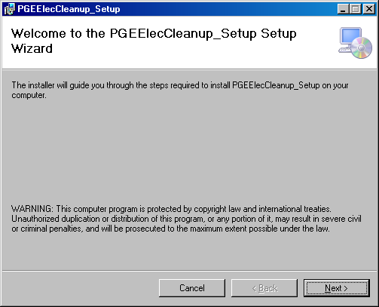
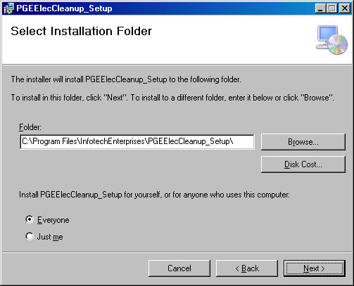
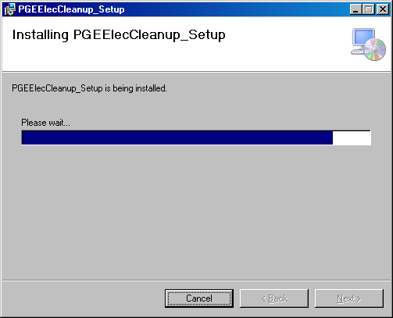
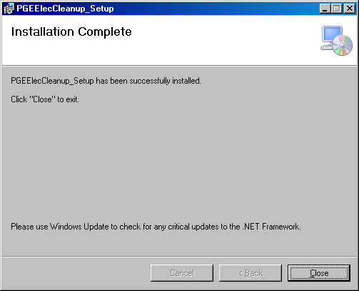

Open PGEElecCleanup.exe from installed path. It opens below GUI.
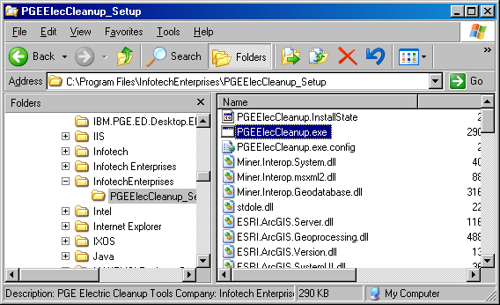

Select tab Database->Connection, following Spatial Database connection GUI form will be opened
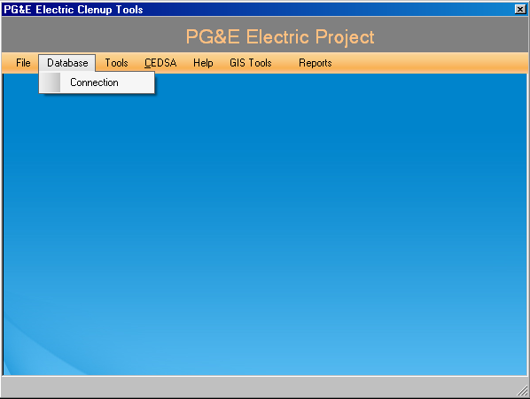

-Provide the SDE connection details (Replace production database name inplace of edgism2q).
-Then all SDE versions available are displayed in combo box.
-Select the version which is created in Arc Map to run the tool.

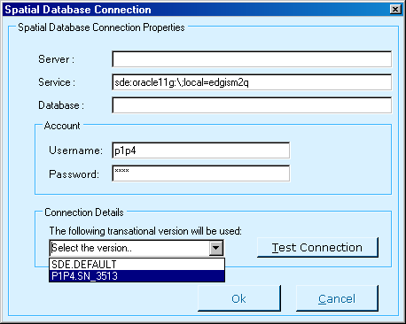
Test connection established for a selected versioned database, Click on OK if test succeed
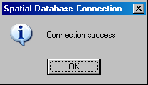

Select tab Tools->ValidateTrans_Downstreams_CondChk,it will opens below GUI.

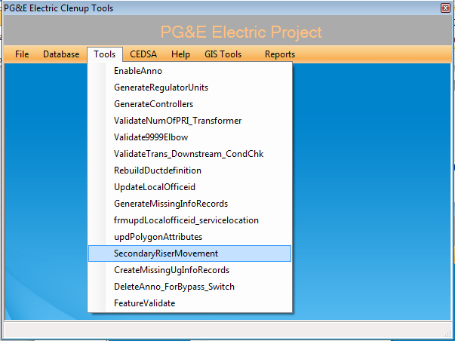

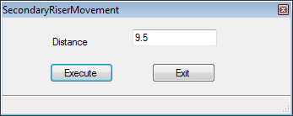
Select Execute button to run the tool.
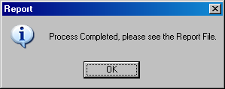
Log files will be generated at path C:\PGE_Reports.
After Verifying the tool results this session will need to be posted to default through GDBM.

